Introduction of the City of Cuxhaven as potential site for a Chinese Production of Goods for the European Market
In 2003 the German Federal State of Lower Saxony (Niedersachsen) and the City of Cuxhaven established the Master plan for the development of the Port of Cuxhaven. Following this plan Cuxhaven today provides ideal infrastructural facilities and unique characteristics, tailor made to meet the requirements from the production sector.
Advantages:
- Special port infrastructure: Heavy Load Quay, Offshore Terminals I and II, extension of the Europe Quay Multi Purpose Sea Terminal (2014)
- Extensive real estate available for manufacturing purposes
- Excellent geographical location to North European and Baltic destinations
- Close geographical location at Northern Europe’s most important sea transport routes
- Direct access to the international road and railway system
- Nearby Sea-Airport Cuxhaven / Nordholz, distance 15 km (with offshore-helicopter base)
- Multipurpose deep-water terminal for any size of vessel
- Experienced port service providers, e.g. Cuxport (Shareholders: Rhenus AG & Co. KG, HHLA Hamburg), marine service provider Otto Wulf GmbH
- Synergy effects with established offshore construction companies (Strabag Offshore Wind, Ambau GmbH, Cuxhaven Steel Construction GmbH).

Rhenus Cuxport in conjunction with the City of Cuxhaven, department for economic development, offers a unique service for the settlement of Chinese manufacturing plants.

A team of experts from Cuxport and all local government authorities will focus directly on the needs of the Chinese company and provide tailor made solutions. Without bureaucratic barriers we will deal with all requirements in a very comprehensive and fast way.

Suggested area for manufacturing plant or a car storage facility:
The facility for the production plant or storage of import cars could be located on the area of the Building Plan 113/2 (Figure 1). This area comprises 11ha in the direct vicinity of the production facilities of Strabag Offshore Wind, AMBAU GmbH und CSC (Cuxhaven Steel Construction). The building permit is presently under development, will be completed in autumn 2012 and ready to be used latest beginning of 2013.
Figure 1: Area for Production Plant or Car Storage

Further industrial real estate areas are under development in Cuxhaven.

Logistic Concept for a Manufacturing Plant in Cuxhaven
Transport Connections
Maritime Traffic:
Cuxhaven is situated at the mouth of the river Elbe into the North Sea. Fast and easy access to all major sea routes is provided. The Elbe River navigation fairway has up to 15 m waterdepth and a width of minimum 400 m.
All major quays of Cuxhaven port are deepwater and easily accessible for all types of ships from the navigation fairway without any locks. Cuxhaven has regular RoRo-ferry links to Immingham / UK (abt. 6 departures per week) and to the Baltic. Travel time between Cuxhaven and the Immingham/Hull area in UK is about 22 hours.
Inland River Navigation:
Via the Elbe river Cuxhaven is connected to Hamburg and the German inland river- and canal system.
Rail Connection:
Cuxhaven port is linked to the German railway system via Bremerhaven and Hamburg Maschen, which is Europe´s biggest marshalling yard. Daily railway connections already today form part of fast and economic supply chains (steel- and paper products, new car logistics, etc.) linking continental Europe via Cuxhaven to i.a. UK destinations. Rail is also the fastest passenger link between Hamburg and Cuxhaven (1.75 hours).
Road Connection:
Cuxhaven is linked via the motorway A 27 (-> Bremen) to the German motorway network, guaranteeing quick and efficient transport solutions from/to industrial production centers in Germany and continental Europe.
Air Connection:
The airport of Nordholz is only a 20 minute car ride away from Cuxhaven. This airport presently is being further developed as the offshore-wind-energy service airport in North Western Germany. The airport of Bremen (abt. 1 hour away) is the next located international airport.

Port Facilities:
Berth Capacities
The Port of Cuxhaven provides up to 6 deepwater berths suited to handle all types of vessels. Additional shallow water berths are available to act as maintenance and service base for offshore windparks.
Port Storage:
Each berth has a minimum of 2-4 hectares adjacent short term storage capacity.
Port Equipment:
Fork lifts of up to 32 t and reachstackers of up to 45 t are available. Cranage includes a 100 t mobile harbour crane plus one 600 t heavy lift gantry crane. Additional mobile heavy lift cranes and also SPMTs can be booked.
Stevedoring:
The main stevedoring company is Rhenus Cuxport. This terminal operator has ample experience in the handling of unitized and project cargoes, including components for offshore windenergy turbines. The company is a joint venture of Rhenus Logistics, one of the biggest international logistic companies, and HHLA, the biggest port operator in Hamburg.
At Cuxport an experienced and privately managed pool of well trained and certified port workers is available.

Inbound Logistics
Material sourced in Europe
For the purpose of this introduction material imported from Asia or sourced in Europe is considered. For the latter it is assumed that all incoming cargo sourced from European suppliers will be delivered via trailer/container straight to the manufacturing plant.
In case that also rail-traffic needs to be considered cargo transfer from the Cuxport railhead to the manufacturing plant can easily be performed.

Material sourced in China
Breakbulk shipments
Considering regular breakbulk imports from China regularly trading multi purpose vessels used on part cargo basis could be deployed. The Cuxport Terminal can easily handle such vessels using terminal own shorecranes (Container plus harbour mobile crane). Discharged cargo may then be temporarily stored at Cuxport and subsequently be transferred “in time” via mafi trailer using port internal roads to the manufacturing plant.
Containerized shipments
Cuxhaven is located at about 40 km, respectively 100 km distance from the international container ports of Bremerhaven and Hamburg, which are served by regular international container lines (e.g. COSCO or China Shipping) trading between Asia and Europe. Depending on the delivery pattern from Asia (based on individual container shipment or on consolidated shipments of container groups) either truck haulage from the respective port of entry or biweekly/monthly transfer by barge from Hamburg could be possible.
Individual container shipments from the ports of Bremerhaven or Hamburg could be routed straight to the receiving station of the manufacturing plant. Lots transported by barge from Hamburg could be routed via the Cuxport Sea terminal.

Outbound Logistics
- For offshore wind turbines
Our present suggestion focuses on the production of offshore windenergy components, comprising initially abt. 100 turbines p.a.
The dimensions for the turbines are estimated to measure 8x8x20 m and to weigh up to abt. 500 metric tons.
Movements of turbines from production to storage and quay:
Assumed that production will have an output of 100 turbines p.a. a minimum of 200 turbine moves (production to storage, storage to quay) need to be considered. Provided a production time of 15 – 20 years the provision of 1-2 sets purpose built SPMT (Self Propelled Modular Transporter) will be viable. As Cuxhaven also is the center of steel foundation construction for offshore turbines there is potential for additional use of the suggested SPMTs which can help decrease the associated cost for all movements. Shipment of turbines can be performed at various berths 9, 8, 4 and 3, (see figure 2, port map) depending also on the necessity to „jack up“

Figure 2: Port Plan
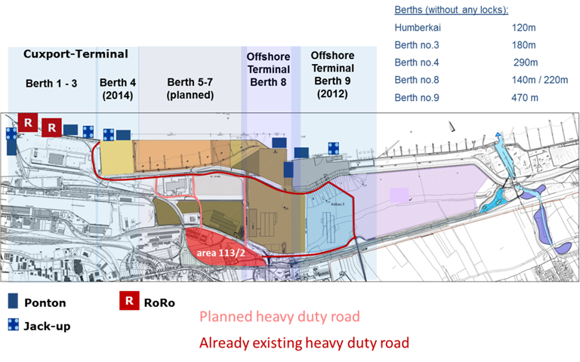

Shipment to offshore windfarms, UK and other destinations:
Loading of the turbines may be performed by:
- installation jack-up vessel
- geared heavy lift vessel
- the 600 t heavy lift gantry crane
- by heavy lift crawler crane
- rolling on SPMT at any suitable berth.

- For import of new cars produced in China for the European market
This suggestion focuses on the assumption that Cuxhaven is used as the main north European maritime entry for imported cars produced in China. Such cars would be brought from China using modern RoRo-ships with a capacity of up to 6.000 cars.

Movements of cars from the port facility to the storage center:
It is assumed that about half of this volume will be discharged in a southern or western European port, the balance of abt. 2.500 – 3.000 cars will be discharged at the Cuxport sea terminal. The cars will then be transferred via a port internal non public road to the storage center, where they will be stored in multi story car parks to be erected on the suggested production area.
In addition to the storage facility also technical workshops will be set up in order to execute last minute technical jobs necessary to bring the cars to the European market or in accordance with specific requirements of the dealers.
Distribution to the dealers/market:
The storage facility will have it’s own rail and road access. Distribution via road to north German destinations and via rail to southern Germany and south eastern / central European destinations.
Furthermore distribution to UK and Baltic/Scandinavian destinations will be performed via the existing short sea liner services working from Cuxhaven.

Cuxhaven, June 7th, 2012
Hans-Peter Zint
Port Association of Cuxhaven
Member of the Board

